***Rhizomucor miehei* protease (RMP) = *Positive Control***

C:\Users\dell\Desktop\Others Papers\Shilan\Manuscript\Figs\Fig.3.tif

**Fig 1.** Site-specific molecular docking. Demonstration of 2D interactions between RMP protease and κ-casein at which the hydrogen bond forming residues are highlighted in green color

**C:\Users\dell\Desktop\Others Papers\Shilan\Manuscript\Figs\Fig.4.tif**

Fig 2. MD analyses of RMP at different temperatures. **(A)** Plotted RMSD. **(B)** Plotted SASA values. **(C)** Plotted Rg values. **(D)** Plotted number of H-bonds.

**Table1.** The average values of RMSD, SASA, H-bonds and Rg of the RMP at different temperatures.

|  |  |  |  |  |
| --- | --- | --- | --- | --- |
| **Temperature** | **RMSD (nm)** | **SASA (nm2)** | **H-bond** | **Rg (nm)** |
| **30 °C** | 0.1658 ± 0.098 | 154.589 ± 3.8 | 265.251 ± 7.39 | 2.040 ± 0.136 |
| **40 °C** | 0.1725 ± 0.035 | 155.0931 ± 4.56 | 261.640 ± 11.53 | 2.042 ± 0.237 |
| **45 °C** | 0.1604 ± 0.067 | 154.380 ± 7.26 | 267.445 ± 9.67 | 2.037 ± 0.185 |
| **50 °C** | 0.1925 ± 0.073 | 156.833 ± 5.67 | 260.694 ± 13.89 | 2.043 ± 0.214 |
| **60 °C** | 0.2204 ± 0.032 | 158.179 ± 3.98 | 257.825 ± 12.93 | 2.044 ± 0.397 |

C:\Users\dell\Desktop\Others Papers\Shilan\Manuscript\Figs\Fig.5.tif

**Fig 3.** Plotted RMSF of RMP protease (2ASI) at different temperatures

**Table 2.** The average numbers of RMSF values at different temperatures for WT protease (2ASI)

|  |  |  |  |  |  |
| --- | --- | --- | --- | --- | --- |
| **Temperatures** | **30 °C** | **40 °C** | **45 °C** | **50 °C** | **60 °C** |
| **RMSF (nm)** | 0.099698 ± 0.011 | 0.106492 ± 0.037 | 0.098402 ± 0.0128 | 0.116641 ± 0.0253 | 0.12019 ± 0.028 |

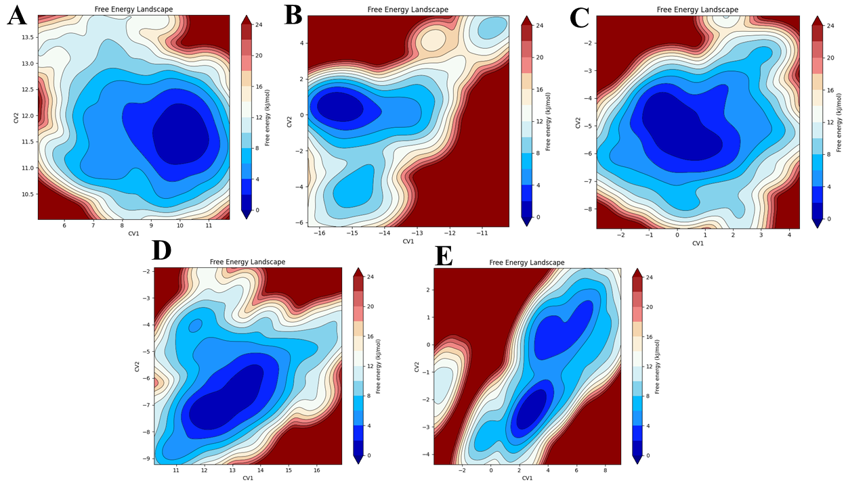

**Fig 4.** Free energy landscape (FEL) analyses of RMP protease (2ASI). **(A)** 30 °C **(B)** 40 °C **(C)** 45 °C **(D)** 50 °C **(E)** 60 °C.

C:\Users\dell\Desktop\Others Papers\Shilan\Manuscript\Figs\Fig.7.tif

**Fig 5.** Principal component analysis (PCA) of WT protease (2ASI). **(A)** 30 °C **(B)** 40 °C **(C)** 45 °C **(D)** 50 °C **(E)** 60 °C.

**Table 3.** MM-PBSA values of RMP at different temperatures

|  |  |  |  |  |  |
| --- | --- | --- | --- | --- | --- |
| **RMP (2ASI)** | | | | | |
| **Temperatures** | **30** °C | **40** °C | **45** °C | **50** °C | **60** °C |
| **MM-PBSA (*kcal*/*mol)*** | -20.34 | -27.35 | -33.9 | -31.33 | -29.21 |

**Negative control:**  was selected as peptide with low predicted affinity for Pepstatin A based on machine learning

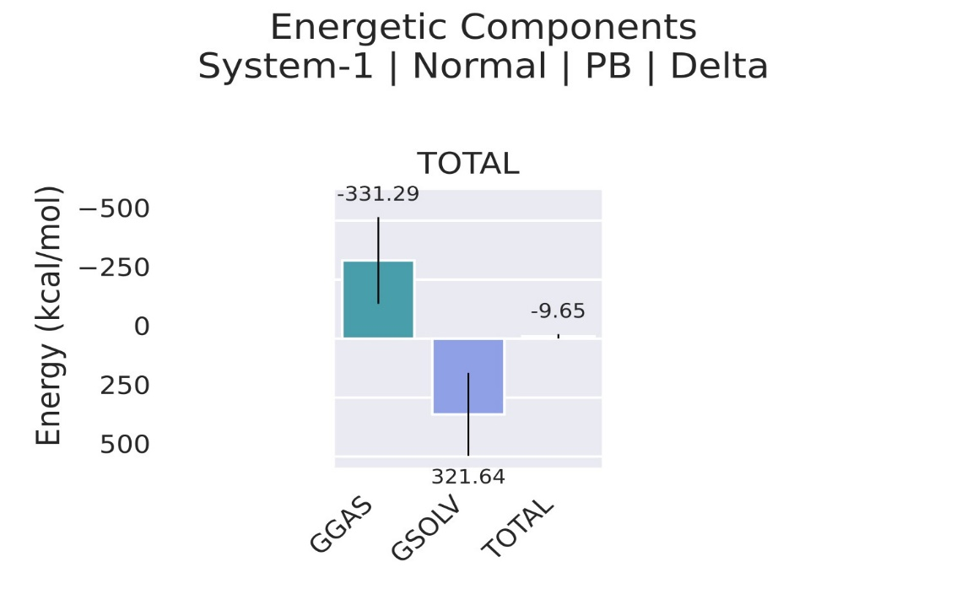

**Fig 6. MMPBSA of negative control is -9.65 (kcal*/*mol)**

**Table 4:** Cross-reactivity analysis of 17 high-affinity peptides against non-target caseins identified six peptides with low cross-reactivity and strong Pepstatin A binding

|  |  |  |  |  |  |  |
| --- | --- | --- | --- | --- | --- | --- |
| No | Peptide Sequences | Pepstatin A | αs1-casein | αs2-casein | β-casein | Total Cross Reactivity (TCA) |
| 1 | LFDTGSSVDEMTRDTGTNFFI | 5.325473 | 0.1252 | 0.0995 | 0.1389 | 0.3636 |
| 2 | LFDTGSSVDESTRDTGTNFFI | 5.318731 | 0.1069 | 0.0829 | 0.1179 | 0.3077 |
| 3 | LFDTGSSADEMTRDTGTNFFI | 5.315047 | 0.1052 | 0.0812 | 0.1162 | 0.3026 |
| 4 | LFDTGSSVDESTKDTGTNFFI | 5.313759 | 0.1627 | 0.1322 | 0.1784 | 0.4733 |
| 5 | LFDTGSSGDEYTKDTGTNFFI | 5.312084 | 0.1933 | 0.1598 | 0.2092 | 0.5623 |
| 6 | LFDTGSSVDEYTKDTGTNFFI | 5.311746 | 0.2428 | 0.2008 | 0.2607 | 0.7043 |
| 7 | LFDTGSSGDETTKDTGTNFFI | 5.311209 | 0.1487 | 0.1184 | 0.1631 | 0.4302 |
| 8 | LFDTGSSVDETTKDTGTNFFI | 5.311182 | 0.2000 | 0.1661 | 0.2162 | 0.5823 |
| 9 | LFDTGSSGDESTRDTGTNFFI | 5.311155 | 0.0913 | 0.0696 | 0.023 | 0.1839 |
| 10 | LFDTGSSGDEMTRDTGTNFFI | 5.31098 | 0.1046 | 0.0806 | 0.1156 | 0.3008 |
| 11 | LFDTGSSADESTRDTGTNFFI | 5.309219 | 0.0940 | 0.0717 | 0.1049 | 0.2706 |
| 12 | LFDTGSSADESTKDTGTNFFI | 5.309185 | 0.1423 | 0.1121 | 0.1560 | 0.4104 |
| 13 | LFDTGSSVDEYTRDTGTNFFI | 5.309083 | 0.1816 | 0.1493 | 0.1973 | 0.5282 |
| 14 | LFDTGSSVDETTRDTGTNFFI | 5.308874 | 0.1446 | 0.1143 | 0.1585 | 0.4174 |
| 15 | LFDTGSSADEYTKDTGTNFFI | 5.308703 | 0.2015 | 0.1673 | 0.2176 | 0.5864 |
| 16 | LFDTGSSADETTKDTGTNFFI | 5.308214 | 0.1581 | 0.1278 | 0.1736 | 0.4595 |
| 17 | LFDTGSSGDEYTRDTGTNFFI | 5.30717 | 0.1559 | 0.1256 | 0.1710 | 0.4525 |
|  |  |  |  |  |  | 0.431529 |

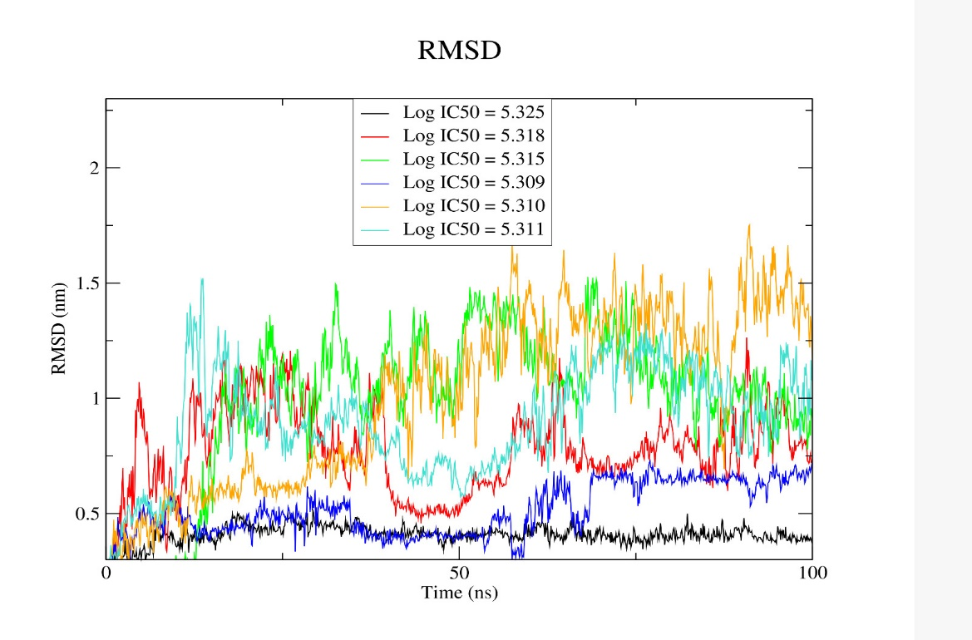

**Fig 6:** RMSD profiles of the six top candidate peptides generated and evaluated through molecular dynamics (MD) simulations. The analysis was performed to investigate their structural stability and dynamic behavior over time, providing insight into their conformational flexibility relevant to κ-casein binding.